**FOURTH SEMESTER ECD PROJECT REPORT**

**TEMPERATURE DETECTOR**

Electronics and Communication Engineering.

# Submitted by

HARSHA VARDHAN 210907194

NAKSH JAIN 210907212

SOUMIL JAIN 210907208

SECTION-A

DEPARTMENT OF ELECTRONICS AND COMMUNICATION ENGINEERING

MANIPAL INSTITUTE OF TECHNOLOGY

(A Constituent Institution of Manipal Academy of Higher Education) MANIPAL – 576104, KARNATAKA, INDIA

**ABSTRACT**

Have you ever driven on a hot day with your phone still in the car? If such were the case, your screen could have shown a thermometer graphic along with a notification indicating your phone had overheated. This is because your phone's internal temperature is being measured by a tiny integrated temperature sensor. The temperature sensor that has been used in this project is LM35. The LM35 is a high-precision, low-cost, low-power temperature sensor. The voltage output from this IC is directly proportional to the temperature change.

The LM35 senses the surrounding temperature and sends a signal to the opamp. The opamp acts like a comparator and compares the preset voltage and the voltage given by LM35 and sends the output. Based on the output of the comparator green LED or Red LED is switched on, thus detecting when the surrounding temperature reaches a certain value.

The main result obtained by the OP-AMP is that, when the surrounding temperature is lower than the preset temperature, green LED is switched on and when it is higher, then Red LED is switched on. The surrounding temperature can be monitored and controlled this way.

We can also use the circuit to detect a specific temperature.

Often, a temperature detector will be crucial to an application. The responsiveness and precision of the temperature detectors are crucial in many situations where keeping a certain temperature is important, such as when items need to be kept at a given temperature or when patients need to be monitored. Temperature detectors are an essential tool in a wide range of industries, including food processing, petrochemical handling, automobile monitoring, biological research, HVAC (Heating, ventilation and air conditioning) and many everyday electronic products.

**INTRODUCTION**

*1.1 Introduction:*

In order to record, monitor, or communicate temperature changes, a temperature detector is an electronic device that monitors the temperature of its surroundings and turns the input signals into digital signals. Temperature detectors come in a wide variety of forms. Non-contact temperature sensors detect an object's temperature without making direct touch with it, whereas contact temperature detectors must make contact with the physical thing being monitored.

There are non-contact temperature detectors also available and frequently used in many devices. They are known as IR (Infrared) sensors, and they get a signal from a calibrated electronic circuit that measures the temperature of the object after remotely detecting the IR radiation that an object emits.

But in this project, we have used LM35 which works on physical touch and detects the temperature change. In comparison to linear temperature sensors calibrated in Kelvin, the LM35 device has the benefit that the user does not need to deduct a significant constant voltage from the output to get suitable Centigrade scaling. It is a 3-terminal sensor that is used to gauge ambient temperatures between -55 °C and 150 °C. The LM35 is 10 mV/degree Celsius sensitive. Output voltage rises along with temperature. The temperature output from the LM35 is more accurate than the output from a thermistor.

In this project we have also used an OP-AMP which is LM741. An integrated circuit (IC) that functions as a voltage amplifier is known as an OP-AMP. There is a differential input on an OP-AMP. It therefore has two inputs with opposite polarity.

The LM741 is one of the most well-known operational amplifier integrated circuits, capable of both amplification and mathematical calculation. It just contains one op-amp and the inverting and non-inverting signals are compared using an operational amplifier as a comparator. This op-amp is, in a nutshell, the greatest option for analogue circuits.

*1.2 Significance:*

Around the world, temperature detectors are used for a wide range of practical applications in numerous industries. In essence, these detectors give information to a system that helps it estimate or precisely detect the temperature of a certain object or environment. While you might just believe that temperature detectors are used to determine an object's or environment's temperature, they are actually used for more complex purposes. Many temperature detectors are used to determine whether a process is occurring within a certain range in addition to measuring things like this. Temperature detectors are mostly used in preventive reliability, which helps verify that a system is working properly and identify any coming risks of hazard or failure.

Numerous industries, including healthcare, motorsports, HVAC, the agricultural sector, the aerospace industry, and automotive, use temperature detectors. The following list includes some of the different temperature detector applications we have come across:-

* Motors - Most motor-related components need their temperatures to be monitored to make sure the motor doesn't become too hot.
* Home Appliances - Temperature detectors are included in kettles, toasters, washing machines, dishwashers, and coffee makers.
* Computers - Temperature sensors are used inside computers to prevent overheating.
* Industrial Equipments - These applications will require robust temperature sensors since the environment might be quite demanding.

Fig 1 : Block Diagram

**METHODOLOGY**

You can detect a specific temperature or control/monitor the temperature using this circuit. The temperature detector circuit has an LM35 sensor. The temperature sensor sends a signal to the non-inverting input of the OP-AMP. You can set the voltage that goes in the inverting input based on what surrounding temperature you want the circuit to detect. The OP-AMP acts as a comparator and gives a different output when one voltage is greater than the other. This different output can be shown by two LEDs, green and red.

*2.1 Detailed methodology*

OP-AMP or operational amplifier acts as a voltage amplifier. The OP-AMP used here is IC741. It has 8 pins in total, 1-Offset Null, 2-Inverting, 3-Non inverting, 4-(-Vcc), 5-Offset Null, 6-Output, 7-(+Vcc), 8-Not connected. The OP-AMP is used as a comparator which means both non inverting input and inverting input are compared and if inverting input is more than the non inverting input then the output is -Vsat. When the non inverting input is greater than the inverting output then the output is +Vsat.

The IC LM35 is used as a sensor in this project to measure exact centigrade temperature. Linearity describes how well a sensor's output varies throughout a temperature range. Precision IC Sensors have a very good linearity of 0.5°C accuracy and a wide temperature range. Its output voltage is proportional to the temperature in degrees Celsius (centigrade). The LM35 can work in temperatures ranging from -55° to +150°C. You should use a preset or potentiometer to adjust the voltage on pin 2 of IC 741 as the trigger point. The objective of this project is to activate or deactivate a gadget at a predetermined margin temperature rather than to construct a thermometer. To keep things simple, we've utilized two LEDs to indicate low (Green) and high (Red) temperatures.

The output of IC2 (LM35) increases by 10 mV/°C in direct proportion to temperature, and this changing voltage is sent into an IC 741 (OP Amplifier) comparator configuration. At pin no.2, we first set sensitivity (a voltage by adjusting the 2K pot). We can easily describe what is happening if we regard the sensitivity voltage as V1 and the output of the LM35 (pin no. 3) as V2. If V1 > V2, the comparator output is at +Vsaturation, and the green LED is on and the red LED is off. The output of the LM35 increases along with the temperature. After a while, when voltage V2 crosses voltage V1, the comparator's output reaches -Vsaturation, which turns on the red LED and turns out the green LED. The output is 0 and both LEDs are off when V1=V2.

*2.2 Component specifications*:

* Breadboard
* OP-AMP 741
* LM35
* Battery
* 470 ohm Resistors
* 10k Resistor
* Light Emitting Diode
* 2k variable resistor
* Wires

*2.3 Justification for component selection:*

LM35 is very precise in measurement of temperature, it has a very good linearity of 0.5 degree Celsius accuracy and a wide temperature range from -55 to +150 degree Celsius. It is a very good alternative to thermistor as it does not require any external calibration.

IC 741 is a good alternative to Arduino Uno as it is cheap and readily available in the market.

LEDs are used to detect an increase in the temperature rather than buzzers because of their simplicity and visual appeal.

*2.4 Circuit layout:*

The images (Fig.1 and Fig.2) given below is the circuit illustration which has been used in our project.

Fig 2 : Circuit Layout

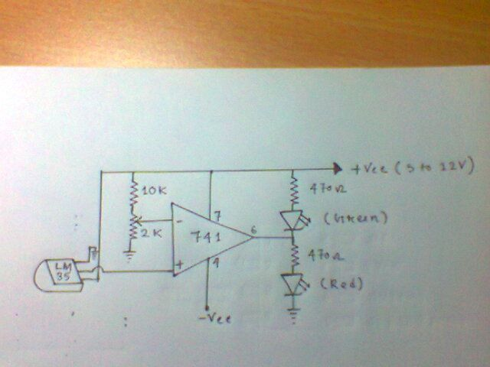

Fig 3 : Circuit Layout

*2.5 Tools used:*

• Screwdriver

• Digital Multimeter

• Wire Cutter

**RESULT ANALYSIS**

*3.1 Result Analysis:*

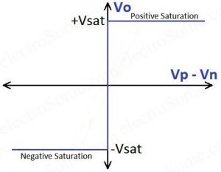

|  |  |  |  |
| --- | --- | --- | --- |
| V1=Sensitivity Voltage  V2=LM35 Output Voltage | Output | Green LED | Red LED |
| V1>V2 | +Vsat | ON | OFF |
| V1<V2 | -Vsat | OFF | ON |
| V1=V2 | 0 | OFF | OFF |

If V1 > V2, the comparator output is at +Vsaturation, and the green LED is on and the red LED is off. The output of the LM35 increases along with the temperature. After a while, when voltage V2 crosses voltage V1, the comparator's output reaches -Vsaturation, which turns on the red LED and turns out the green LED. The output is 0 and both LEDs are off when V1=V2.

**CONCLUSION AND FUTURE SCOPE OF WORK**

*4.1 Conclusion:*

On experimenting with the components following observations can be made

* Temperature Sensing and Monitoring : We can detect the temperature change and use it to monitor several appliances. This also can be used in industries for industrial machinery as continuous temperature monitoring is very important in many sectors of the industry, for example motorsport industry, aerospace industry, healthcare industry etc.
* Threshold Detector : We can detect a specific surrounding temperature. When the temperature crosses a specific threshold that is set by us, the temperature can be detected
* Flexibility and Versatility : The threshold or the voltage sensitivity can be easily set by rotating the 2K potentiometer that we have used. This enables us the vary the sensitivity of the temperature detector.
  1. *Future Scope:*

The Temperature Sensor Market is expected to register a CAGR of 4.6% during the period. Temperature sensors employed using IoT connectivity are expected to speed up owing to the increasing need for COVID-19 testing and screening. In the future, maintenance will rely on sensors instead of being carried out according to a needs-based timetable. Safety will also improve because unsafe situation will be easily predicted. Autonomous sensor technology will become possible. Wireless connections over long distances with an integrated power supply.

**ANNEXURE**

The op-amp used in the open loop mode of operation will operate as a comparator.

A comparator in its simplest form is on an open loop op-amp with two inputs and one output.

A comparator in its simplest form is nothing but an open loop op-amp with two inputs and one output.

It compares a signal voltage applied to one input of the op-amp, with a known voltage called the reference voltage applied to the other input.

The output of a comparator is either positive or negative saturation voltage (IVsat), depending on which input is larger.

The voltage transfer characteristics of the comparator are not as sharp as the ideal comparator. due to the finite slew rate of the op-amp. Higher the slew rate, the sharper the characteristic.

**REFERENCES**

* Analog Temperature detector using uA741 opamp <https://craftronixlab.wordpress.com/2015/03/05/analog-temperature-detector-using-ua741-opamp/>
* LM35 Data Sheet from https://www.ti.com/product/LM35